**Wasteland Settlers White Paper**

1. **ABSTRACT**

Wasteland Settlers is a Role-Playing game about survival, exploration and collecting. In this strange wasteland metaverse, you lead your people to feed, explore and collect NFTs and fill power into the earth's last space shuttle. Players Play-to-Earn by contributing what is found in the wasteland.

We believe metaverses and blockchain provide players immersed and harvesting gaming experience, with economic incentives driven by fairness and automation.

We identified 4 major problems commonly seen in most blockchain games that Wasteland Settlers will address:

**Problem 1 Prepaid tokens to play game**

That brings risk of losing money to players, we believe free to play model is fair for players

**Problem 2 - Similar games and too many copycats**:

Blockchain games need innovation, we’ve seen too many copycats of successful games (eg. copying Axie Infinity), Still, tokenomics is key of success.

**Problem 3 - Hyperinflationary and unsustainable tokenomics**

The popularity of games depends on the design of game tokenomics. Good game tokenomics design will extend the game lifetime, helping players to get more financial returns and keep the game vibrant. Bad tokenomics drains play-to-earn rewards fast as the number of players grows.

**Problem 4 - Tokens safety**

We see founders of a few gaming projects took all tokens and ran away, resulting in all players losing their investment in the game.

We address 4 problems above through our solutions embedded within design of Wasteland Settlers :

* Wasteland is a **free-to-play game**, you don’t need to pay any token upfront to play the game. Everyone is welcome to start enjoying the fun of the game, learning how to play and understanding tokenomics and calculation of ROI. Of course, purchasing tools and chests will help the players to gain more from exploration and rewards.
* Wasteland Settlers is wasteland-type RPG game We are building the wasteland metaverse, players survives in the nuclear-bombed land. **Players don’t need to level up**, simply explore the land and equip their villagers, or increase the power of the space shuttle for launching it one day to find a new planet. Wasteland Settlers is able to **set player profile picture to your own Hero NFT,** e.g. Bored Ape Yacht Club and many other 50 NFTs.
* An unique tokenomics - Contribution Pool, it **solves the problem of Hyperinflationary and that NFTs are hard to sell**. The Contribution Pool takes all NFTs and rewards contributors fairly. Every player enjoys lifetime rewards from the Contribution Pool, the more contributions, the more rewards.
* **The future of this game is driven by the community, in which 85% of $WASTE tokens are distributed to the community**, the DAO tokens are staked and used based on the voting. The projects will move to DAO model of governance. The source codes are open and audited. It’s transparent to all players.

The summary is in below table:

|  | **Most Other Blockchain Games** | **Wasteland Settlers** |
| --- | --- | --- |
| Prepaid to play | Yes | No, it’s free to play |
| Copycats game | Yes | New design and new gameplay, No levelup |
| Hyperinflationary and unsustainable tokenomics | Yes | Unique Contribution Pool tokenomics to balance the game economy |
| Project owner ran away? | It happens | 85% of token to the community and code are open and safe |

1. **GAME INTRODUCTION**

**1.1 Game Background**

The civilization of earth was destroyed by the alien raiders. After millions of nuclear missiles devastated our green homeland then Aliens flew away with robberies of gold and other rare metals. Earth has turned into a wasteland where survival is the primary objective.

Survivors in different places were searching for foods to eat, weapons and dresses to equip, they finally found a small piece of green land to settle down. You, as one of survivors, opened your small magical box, and the light of a space shuttle shone in the small village, it’s a portal to the space shuttle. The space shuttle is your last hope to survivors, it’s the only ship on the earth, launching it by filling power will bring the survivors to a new planet.

As the leader of the group, you need to assign jobs to your people, let them explore new strange places, collect items, defeat your enemies and boost power to space shuttle through the portal. You will earn rewards for what you’ve done to the hope of humanity.

* 1. **Gameplay**

This game is a survival, exploration and collecting game. You are the leader of your people, you found an ideal place for your people to settle down. This place has clean water, woods, fruits and animals in the nearby forest. You decided to settle down here and build your hut, hall, warehouse.

And you’ve already known that the goal for the game is to collect as many items as possible from exploring, and send it to the spaceship to get a reward. You need to assign jobs to your people.

In the very beginning, you don’t have many followers with you, only Adam and Eve. Those two villagers are the survivors you found on the way here, and they are free villagers given by the system, and non-transferrable NFT, which means you can’t trade them to other players.

There are a few jobs the villagers can do to survive.

* Hunting and picking fruits for getting your food, your villagers can’t do almost anything without food, so make sure you have enough food to live on.

There are different food types, supplying different food types will make your villagers happy. Your villager wants roast, wine, bread and sausage, they are not satisfied with only strawberries. You need to feed them at least 3 different foods to make them happy to have the full power to do the job. It seems they are spoiled way before the alien invasion.

* Exploring is the most important job to do. After you have enough food, you need to send your villagers to explore the strange wilds. The exploration is dangerous, it’s better to have your villager well equipped. Sometimes, your villagers can find something exceeding your expectations. Your villager may find other survivors, dogs, or weapons and other items. Those will make your villagers stronger and let your village grow faster.
* Giving birth is one of the ways to grow your people, send your male and female villagers to the hall and give them your blessing, increase their happiness, and they may get pregnant and deliver a child. It takes a long time, but you need to be patient.

In the center of your village, the portal to the space shuttle shines. You send what you’ve collected from the exploration, and you will get rewards every day. The contribution, it’s very important to know your contribution points, it determines how much rewards you can get. Of course, once you send your NFTs to the portal, you won't be able to use it again.

* 1. **Jobs**

**2.3.1 Hunting**

When you ask your villager to hunt, he will go to the woods and hunt animals and bring meat back. Each hunting time is 24 hours, each successful hunt villager will get 4 meats. And your villager’s attributes will determine how many meats and how long for the hunting. You may find more information on Attributes in the next chapter.

Let your villager hunt, simply click the villager in your home, or click the name of the villager from your villager list, and then click ‘Hunt’. Your villager will go to the woods and hunt automatically, you just need to wait for his/her return.

Please be aware that Hunting requires foods to do the action, foods can give your villagers happiness and Happiness will determine the efficiency of your hunting. You may find more information on Happiness in the next chapter.

**Strength Attribute**: Strength determines the number of shooting animals during one trip.

Number of shooting = 1 + Strength/20

**Endurance Attribute**: Endurance determines the total hunting time, the higher the Endurance, the less hunting time.

Hunting time(hour) = 24 – (Endurance – 20)/20

If Endurance < 20, then the Hunting time = 24

**Luck Attribute**: Luck determines the ratio of Double Hits, Double Hits will give you 8 meats in one shot.

Double Hits Ratio = ((Luck – 20)/150)2 + 10%

If Luck < 20, then Double Hits Ratio = 10%, that’ll give you a minimum of 10% of Double Hits ratio.

Tools you can use – **Bow**

**Bow** can be purchased directly from the game Market, it requires the game token WASTE to purchase.

Bow can highly increase the villager’s hunting efficiency, it will give you 12 meats instead of 4 meats in one shot. If you get a Double Hits, that’ll give you 24 meats.

**2.3.2 Picking Fruits**

Picking fruits is the easiest way to gather food to your village, it doesn’t require feeding the villager to do so. The algorithm is the same as Hunting, except that the village picks 1 fruit at a time.

Tools you can use – **Basket**

**Basket** can be purchased directly from the Market, it requires the game token WASTE to purchase. Basket can increase 2 times of the villager’s production.

**2.3.3 Exploring**

Exploring is the most important job of the game, it’s the only way to collect NFT items. Sending the villager out to explore, he will find Chests when he returns. When you open these Chests, you can find new villagers, weapons, dresses and even pets. Those NFTs equipped to your villager will highly increase his/her efficiency to perform exploring and other jobs. And of course, don’t forget to send those NFTs to the Portal to earn hourly rewards.

**Length Attribute**: It determines the Number of events during the exploring.

Number of events = (Length/120)2 * 10 +1

**Endurance Attribute**: it determines the exploring time, the longer of it, the more Chests you can find.

Exploring Time (hour) = $\sqrt{Endurance* 1.2}$ + 24

**Luck Attribute**: It determines the exploring success ratio. It’s the ratio to collect a Chest when the villager encounters an event. For each extra 2.5 hours you spent exploring, the villager can get 2% more success ratio.

Exploring Success Ratio = Luck/200 + (Exploring Time-24)/2.5*2%

**2.3.4 Giving Birth**

You may find a Hall in your village, it’s the place for your male and female villagers to give birth to a baby. To get the female villager to get pregnant, you need to provide foods to increase her Happiness, it’s very important since her Happiness will determine the baby’s attributes.

Child Attributes = ((father attributes + mother attributes) * 50%) +/-15%

That means the child’s strength, endurance and luck is the average of his parents, but with 15% up more less.

The 15% of up or less depends on the happiness of mother delivery. The mother needs food and happiness to deliver a baby. If you feed the mother only 13% happiness, then the baby attributes -15%. If you feed the mother 100 Happiness, then the baby attributes +15%.

So, it’s very important to keep the mother happy before you decide to deliver a child. Villager NFTs are very rare, I believe this investment can bring you more return.

The Child needs 15 days to grow as an adult, before that, all of his attributes are only 30%, and even if you send him to the Contribution Pool, it’s still only 30% of his attributes. Child can’t go exploring, but you can ask him to hunt and pick fruits.

The female villager will get pregnant very soon, but you can’t assign her to explore, that’s too dangerous for pregnant women and children.

It’ll take about 20 days for the female villager to deliver her child, the child’s attributes are average of his parents.

**2.3.5 Player VS Player Fighting (PVP)**

PVP Fighting is another way to get rewarded, different PVP ranking gives you different rewards weekly.

You can send 5 villagers at the most to fight at the arena. Pick another player’s name in the ranking board and you can ‘Challenge’ him. The winner will take the loser’s place and the loser’s ranking declines.

The 5 villagers will fight in a turn base, winning depends on the villager’s attributes.

You don’t need to feed villagers to fight with other players, and Happiness won’t affect villagers’ attributes. And working villagers can join PVP fighting without interruption of their current job.

**3. GAME ASSETS**

**3.1 Village**

When you start the game at the first time, you are assigned a village on the wasteland, with some buildings by default.

**Portal**: In the center of your village, you will find the spaceship portal, you can contribute your collected items through the portal. Your contributed items will be transferred to the spaceship automatically, and you will be rewarded for what you’ve done.

**Hut**: You have a hut which can let 5 villagers live in, of course kids also count.

**Warehouse**: A warehouse is used to store items. The warehouse is only for temporary use. We highly recommend you equip your game characters with items or send items to the portal for rewards.

**Hall**: This shabby hall is the place for some important events, like marriage, PvP rewards etc.

**Market**: You can sell your game items and buy items here. In the very beginning, food is very important for a villager to survive. You’ll need to ensure your villagers have full energy. You may need to buy food from other players. Remember, they are all your friends, sometimes, they will give you a lot of help.

**3.2 Player Identity**

A player in the Wasteland Settlers has an identity NFT with different colors. Different colors give a player’s characters different bonuses when they are assigned to a job.

There are 4 different colors for Player’s Identity NFT: **Gray**, **Green**, **Blue** and **Orange**. The default color of a player is Gray. A player can purchase a Green, Blue and Orange color Identity NFT from our presale or trade his Identity NFT with other players. Green, Blue or Orange Identity NFT will help you grow much faster than Gray Identity NFT.

**Gray Identity** - The default identity, it makes no change to your villager’s attributes.

**Green Identity** - Increase all player’s villagers attribute 7% when the villager has a job assigned.

**Blue Identity** - Increase all player’s villagers attribute 14% when the villager has a job assigned.

**Orange Identity** - Increase all player’s villagers attribute 21% when the villager has a job assigned.

The Identity NFT is tradable, it increases villagers’ working efficiency, but it won’t increase your villagers’ Contribution Points.

There are other privileges for Green, Blue and Orange identity holders:

1. Unique profile picture, rare traits for hair, eye and skin colors.
2. Shining profile picture, special frame with your purchased color for all your villagers too.
3. Colored framed profile picture on your PVP ranking list.

**3.3 Villager**

A villager is a character of the Game. Each villager has different attributes as follows, which may help you do a better job. .

* **Name**: The name of the villager, it’s assigned a name and you can change it once and only once.
* **Sex**: Male or female. One male and one female can live together and get the female villager pregnant.
* **Strength**: It determines how many you can get from activities(hunting, exploring and picking fruits).
* **Endurance**: It determines how long it takes to hunt, explore and pick fruits.
* **Luck**: It determines the ratio of finding better items.
* **Happiness**: It determines the efficiency of hunting, exploring and picking fruits, provides various foods to your villagers increase his/her happiness.
* **Activity**: Your villager’s current job, or idle.
* **Carriage**: What the villager currently carries.

**3.4 Happiness**

Villager's Happiness is very important, as it results in different efficiency of the villager to perform his/her job. Each villager has 100 maximum happiness points, which eating different foods will increase the same amount of Happiness. Happiness equals the villager’s efficiency, you’d better make the villager happy before assigning a job to him/her.

First, let’s know more about our food system. There are five different food types, different foods can be produced by different tools, and each of different foods has different happiness points. You can feed the villager 1 food from each food type only, for example, you can feed him/her grapes and then you can’t feed him/her wine anymore.

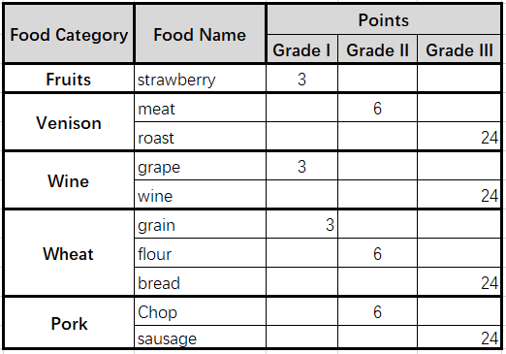

If the villager is fed with 3 different food types from Venison, Wine, Wheat and Pork (fruit is not countable here), the villager will get extra points. If these 3 foods are all Grade III food, he will get extra 18 happiness points, otherwise, he gets extra 3 points. For example, he had Meat, Bread and Sausage, he will get extra 3 points, because Meat is not Grade III food.

The calculation of the villager’s Happiness:

Base Points (10 points) + fed foods points + extra points

The villager’s efficiency is the villager’s Happiness/100, to let the villager do a job at 100%, you’d better feed him 3 different Grade III foods. For example, If he was fed strawberries, meat, grapes, grain and chop, he had 10 base points + 21 food points +3 extra points = 34 points. Then the villager had only 34% of the efficiency, which means each of the villager’s attributes is only 34% of his original attributes.

You don’t need to feed the villager for Picking Fruits.

Since Happiness affects the villager’s working efficiency, your villager may not finish his job when the time is finished. If the villager's time is exceeded, the villager will continue to work, until he gets a successful hunt or collects a Chest. Villagers may spend more time than you expected, but you don’t have to worry your villager got nothing returned with the time he/she spent on working.

**3.5 Workplace**

There are different workplaces in the Market to help your village grow fast.

Input: some workplaces require input materials to produce, for example, Mill takes 20 grains and produces 20 Flours.

Production time: The time to spend on the production. The workplaces start the production by a player, and players need to click to collect when the production is done.

Production: What’s produced.

Production volume: How many were produced.

Food Points to Fix the Tool: Workplaces need to be repaired after 20 uses, and your villager needs a fixed number of Food Points to repair it.

Check the Figure below for more detailed information.

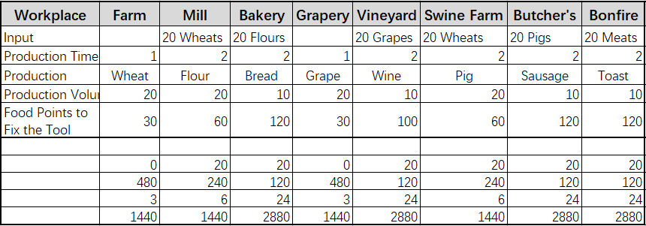

**3.6 Tools**

You can obtain tools from the Market to help your villagers increase their working efficiency.

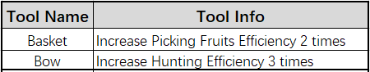

Basket and Bow will increase the efficiency for Picking Fruits and Hunting. Players need more lands when the village is full, need more Huts when you have more villagers.

All tools need to be repaired after 20 uses, and your villager needs a fixed number of Food Points to repair it.

**Others**

If your village reaches the maximum number of buildings, you may buy New Land, which gives you 3 spaces to build more buildings.

Each Hut can dwell 5 villagers, if you luckily find another villager during your exploration, you can buy a New Hut to let him to live. If you reach the maximum housing capacity, your new villagers can only stay in your warehouse and do nothing.



**3.7 Chests**

There are 3 different Chests, and different Chests have different ratios of getting different items and also affect the attribute range of your items.

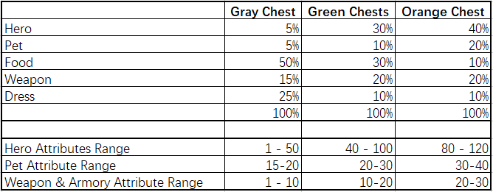

**Gray Chest** can be obtained from exploring, we may airdrop the Gray Chests to early players.

**Green Chests** can be purchased directly from the Market, or through exploring, it’s rare to get through exploring, it’s better to have 100% happiness of your villager and equip him well before sending him out.

**Orange Chest** is not available right now, it will be released soon, and you can’t collect **Orange Chest** through exploring.

**Green Chest** is rare, the odds of getting **Green Chests** increases when you open more chests collected in exploring. If you collected a Green Chest, then your odds are backed to 0.

Green Chest Odds = (Current Chest Number/30)2 * 10



The above chart gives you an idea of the odds to get a **Green Chest**.

**3.8 Villager Equipment**

When you collect NFTs from opening chests, you can wear them right away, to increase your villager’s attributes.

There are a few rules for your villager’s equipment.

* villager’s average attributes (average of Strength, Endurance and Luck) will affect how much equipment the villager can have.
* Once the villager equips wearables, his attributes were changed too.
* You can bring only 1 pet with you at a time.

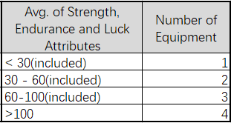

**3.9 Market**

Market is the place players can purchase tools, exchange NFTs with other players. You can sell almost all of your NFTs except Adam and Eve. You need to pay **2.5%** of the traded value for the transaction fee.

You may need to purchase other types of foods from other players and sell what you can produce by your tools. You need to choose smartly and trade carefully.

**4. $WASTE TOKENOMICS**

The $WASTE token is the protocol token from the *Wasteland Settlers* ecosystem. It is an ERC-20 token deployed on the Ethereum blockchain. $WASTE supply is pre-minted with xx million tokens transferred at the deployment and has a supply cap of 1 billion tokens. Players can purchase NFTs with $WASTE in the game, get rewards from the contribution pool, and stake $WASTE to get additional token rewards.

**4.1 $WASTE Token Allocation**

The Wasteland Settlers community owns 85% of the total $WASTE tokens. Others are reserved for private investors and the team. Details of the allocation are listed in the following table.

| Percentage | Allocation | # of Tokens |
| --- | --- | --- |
| 49.50% | 45% Contribution Pool | 450,000,000 |
| 4.5% PVP Rewards | 45,000,000 |
| 7.50% | DAO Treasury | 75,000,000 |
| 7.50% | Team Treasury | 75,000,000 |
| 7.50% | Strategic Sale | 75,000,000 |
| 3.5% | Liquidity Management | 35,000,000 |
| 5% | Airdrop | 50,000,000 |
| 19.5% | Staking Incentive | 195,000,000 |

The $WASTE token is distributed to the participants of the Wasteland Settlers Community including:

* Stakers: $WASTE token holders who deposit their $WASTE that are auto-compounded at each user interaction.
* Players: Game players receive rewards daily based on their playing behaviors.
* Liquidity providers: those who provide liquidity will also receive token rewards.

Some $WASTE tokens, as part of the pre-minted tokens, are vested by strategic sale participants, the Team Treasury, and the DAO Treasury. These tokens are staked at the deployment. Other preminted tokens are airdropped to those who participate in the presale of the Community Membership NFTs and some randomly selected users of some Play-to-Earn games on the market.

**4.2 Token Emission Schedules**

**4.2.1 Play to Earn Reward Schedule**

45% of $WASTE tokens are for Play to Earn rewards. The rewards are halved every three years, and a total of 450 millions of $WASTE tokens will be emitted daily to all players in 11 years.

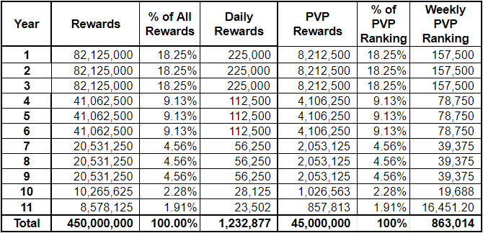

**4.2.2 PVP Fighting Reward Schedule**

The total 5% of WASTE tokens are rewarded to PVP top ranking players. The rewards are halved every three years, and 45 millions of WASTE tokens will be emitted to the top ranking players in 11 years.

**4.2.3 DAO Treasury**

Tokens allocated for the DAO are emitted linearly for staking for about 307 days (or 2,000,000 block time). For every block time, 35 tokens are deposited into the staking pool. Staked tokens are available for withdrawal at the same speed after 90 days (or 585,000 block time) of staking.

**4.2.4 Team Treasury**

Tokens allocated for the Team Treasury are emitted linearly for staking for about 307 days (at the speed of 35 tokens per block time), and are available for withdrawal after 180 days (or 1,170,000 block time) of staking.

**4.2.5 Strategic Sale**

Tokens allocated for the Team Treasury are emitted linearly for staking for about 307 days (at the speed of 35 tokens per block time), and are available for withdrawal after 180 days (or 1,170,000 block time) of staking.

**4.2.6 Liquidity Management**

Tokens allocated for liquidity management are premined and free for staking and trading at the deployment.

**4.2.7 Airdrop**

Tokens allocated for airdrop are premined and free for staking and trading after being airdropped to the community participants.

**4.2.8 Staking Incentive**

Tokens allocated for staking incentives are emitted based on a pre-defined schedule as described in the following table.

| **Phase** | **Length (Blocks)** | **Tokens Per Block** | **Total Rewards** |
| --- | --- | --- | --- |
| A | 195,000 | 240 | 46,800,000 |
| B | 585,000 | 120 | 42,900,000 |
| C | 1,170,000 | 60 | 35,100,000 |
| D | 2,340,000 | 30 | 35,100,000 |
| E | 3,510,000 | 15 | 17,550,000 |
| F | 4,680,000 | 7.5 | 8,755,000 |
| G | 7,020,000 | 3.75 | 8,755,000 |

$WASTE staking rewards per block of Staker A are calculated by:

$\$WASTE staked by Staker A÷Total staked \$WASTE in the pool×\$WASTE per block$

Example:

* Staker A stakes 10,000 $WASTE during Phase A
* The total amount of staked $WASTE at the calculation time is 1,000,000

Based on the above assumptions, Staker A will receive staking rewards:

$10,000÷1,000,000×240=2.4 \$WASTE$ per block

The Wasteland Settlers enables auto-compounding for all stakers who deposit $WASTE to the staking pool. This means that $WASTE token rewards received from the staking are automatically re-staked into the pool.

Tokens received from staking incentives can be withdrawn from the staking pool at any time to a staker’s wallet for use in the game or trading on an exchange.

**4.2.9 Governance**

The Wasteland Settlers community uses the $stWASTE tokens for governance. Participants can receive $stWASTE tokens for $WASTE tokens they stake.

**5. CONTRIBUTION POOL**

**5.1 Contribution Pool**

The Contribution Pool is a unique design, and also the most important part of the game Tokenomics, it determines how much you can get rewarded to play the game. The design of Contribution Pool solves the problem that it’s hard to sell in-game-NFT, especially the game token price goes downward. The Contribution Pool accepts all NFTs and rewards contributors back fairly, it protects players from losing money and let the game play for a long run.

The Contribution Pool contains 5 element pools: Fire, Earth, Metal, Water and Wood. Those five elements are the basic elements for humans to survive, each element pool has an equal and fixed amount of rewards everyday. And a player is informed of the Contribution Points and to what element pool, when he wants to contribute his NFTs through the Portal. The reward is calculated by his Contribution Points VS total Contribution Pools in each different element pool.

Each element pool has an initial 10,000 points, that means the total Contribution Pool can’t be less than 10,000 points. It’s to help players to grow in the very beginning.

If an Element Pool Current Total points < 10,000

Then the Element Pool Current Total Points = 10,000

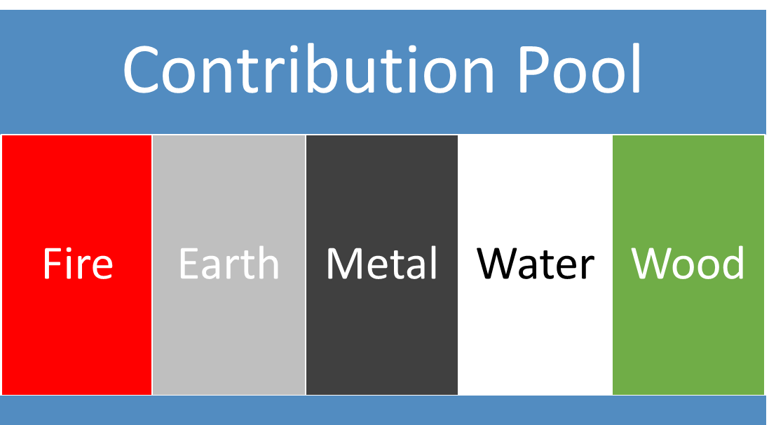

**5.2 Contribution Points**

Different kinds of NFT have different weights under different elements.

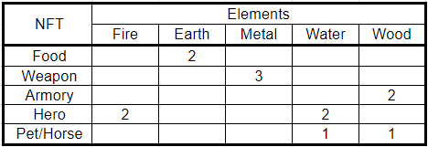

From the table above, we know that food NFT has only Earth elements, and villagers have Fire and Water elements. So, contributing a villager will give you rewards from two element pools.

Each NFT has a basic Contribution Points, it’s the sum of total attributes. For example, strawberries have 3 Food Points, so its basic Contribution Points is 3. villagers basic Contribution Points is the sum of the villager’s Strength, Endurance and Luck.

The weights are multipliers to the Contribution Points.

NFT Contribution Points = Weight * Basic Contribution Points

Since your NFTs have wastage during the teleporting, all your Contribution Points depreciate 5% everyday. You’d better keep exploring to maintain your shares in the pool.

**5.3 Contribution Pool Rewards**

Based on our $WASTE token emission plan, there are 225,000 WASTE tokens awarded daily to contributors for the first 3 years. And each element pool has a fixed amount of 45,000 WASTE tokens to contributors. Everyday, the 45,000 WASTE of each element pool will be distributed to every contributor based on their shares.

Since villager, pet and weapon NFTs are rare, you also need them in your exploration. You'd make a good decision to contribute them, trade them with other players or wear them to increase your working efficiency.

**6. ROADMAP**

| **Major Milestones** | **Timeline** |
| --- | --- |
| 1st NFT Sale - Premium Status | Apr 2022 |
| Game Trailer Released | Apr 2022 |
| 1st Official Airdrop | Apr 2022 |
| 2nd Official Airdrop | May 2022 |
| $WASTE Listing on Uniswap (or other swap) | May 2022 |
| $WASTE Staking Released | May 2022 |
| Closed Beta Test | Jun 2022 |
| Official Game Launch | Jul 2022 |
| $WASTE Listing on CEX | Sep 2022 |
| DAO Proposal | Dec 2022 |
| Version 2 Game Proposal | Dec 2022 |
| Version 2 Development | Mar 2023 |
| Version 2 Released | May 2023 |
| Version 3 Game Proposal | Jul 2023 |
| Version 3 Development | Aug 2023 |
| Version 3 Released | Dec 2023 |